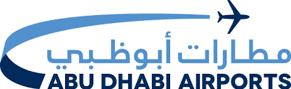
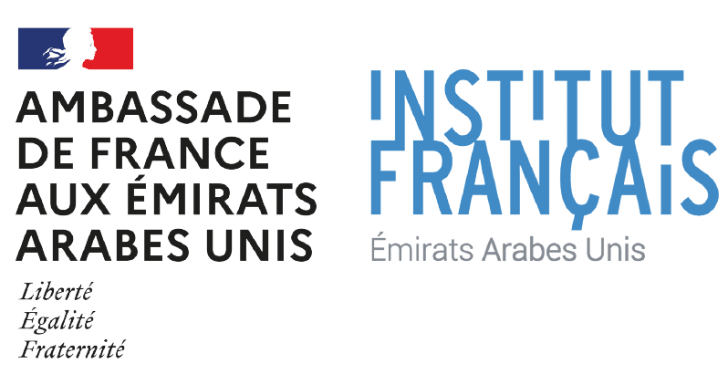
Winners of the Artport Challenger 2022 Announced

Abu Dhabi is Stage for Public Display of Best Photos Taken Linked with ‘City of Music”

Abu Dhabi, UAE, September 21st 2022 –

Following a call for submissions launched on 21 June on the occasion of the International Music Festival, Institut Français in the United Arab Emirates, the cultural department of the French Embassy; JCDecaux, the number one outdoor advertising company worldwide; Abu Dhabi Airports, the operator of Abu Dhabi’s five airports; and Print Works, the local digital printing solutions specialist, are pleased to congratulate the six winners of the Artport Challenge 2022 contest at Abu Dhabi International Airport.

With the competition’s second edition now complete, the partners paid tribute to the liveliness of Abu Dhabi after its designation as “City of Music” by the UNESCO Creative Cities Network in November 2021.

This year, the Artport Challenge contest invited participants to capture the intensity of a musical moment through photography. The competition offered six talented UAE-based photographers, both amateur and professional, the opportunity to exhibit their best photographs on more than 140 outdoor billboards, transforming the capital’s streets and Abu Dhabi International Airport into an open-air gallery starting from September 15, 2022. The winners were divided into two categories: over 15 and under 15-years-old.
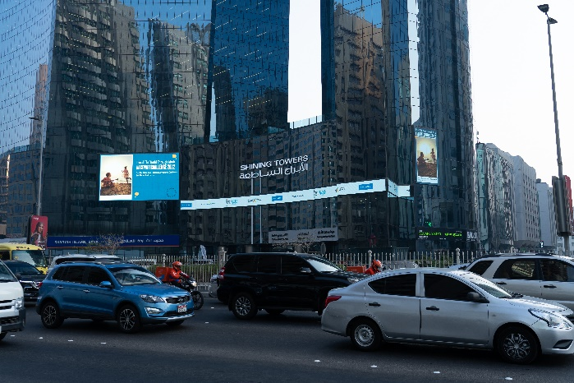
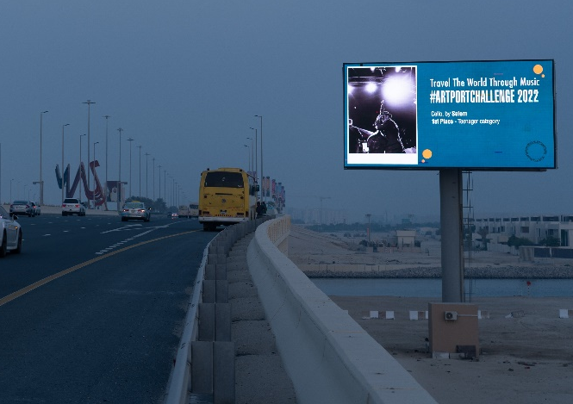

The winners were selected by a jury comprising H.E. Mr Xavier Chatel, Ambassador of France to the United Arab Emirates, Mr Martin Sabbagh, CEO of JCDecaux Middle East and Africa and Jad Khoury, CEO of Print Works. The selection board also included qualified photographers and music personalities, including Jorge Pinto, Strategic Advisor at DCT, Gael Hedding, Executive Director of Berklee Abu Dhabi and Anita Pouchard Serra, Photojournalist & Visual storyteller.

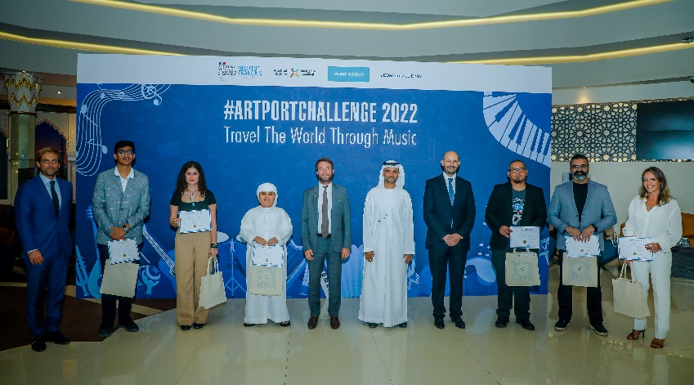

By organizing this annual contest, the four partners aim to increase the local population’s engagement in cultural events and widen access to culture for everyone. The theme of music will undoubtedly shed light on the different musical practices and traditions around the world, with the pictures selected by the jury illustrating the unifying power and universality of music.

H.E Xavier Chatel, Ambassador of France to the UAE, said: "Congratulations to the six winners who have successfully mobilized their artistic skills and imagination to translate musical experience through photographs. The award ceremony was an opportunity to celebrate the friendship between the UAE and France, and the importance that our two countries attach to culture and creation. Music is an important area of cooperation that I wish to deepen between our two countries."

H.E. Eng. Jamal Salem Al Dhaheri, Managing Director and Chief Executive Officer of Abu Dhabi Airports said: “This year’s winners in both categories have excellently demonstrated their musical passion through photography, producing truly outstanding work well worthy of being showcased in public spaces across Abu Dhabi. As such, Abu Dhabi Airports is delighted to extend our congratulations to these talented individuals alongside our partners, who share our vision for welcoming the world to Abu Dhabi, which is, and will always be, an inclusive emirate where arts, culture and music come together for all to experience and enjoy.”

Martin Sabbagh, CEO of JCDecaux Middle East and Africa, said: “We congratulate the winners for paying tribute to the theme of music through beautiful and inspiring photos. They transformed the streets and the airport of Abu Dhabi into an open art gallery, highlighting the role of Abu Dhabi as a global “city of music”. Furthermore, the Artport Challenge contributed to bring creativity to our media allowing classic outdoor to become “Art’door”, a core value at the heart of JCDecaux philosophy. Art has long inspired advertising as much as advertising has been used by artist.”

Jad Khoury, CEO of Print Works said: “Congratulations to the winners of the 2022 Artport Challenge. It is indeed a challenge to successfully translate the art of music into visual art pieces and they did so brilliantly. We were very happy to add our modest contribution to the success of the event and are eager to collaborate on similar projects in the future.”

- Ends –

For more information, please visit:

- www.institutfrancais-uae.com/en/artportchallenge-2022/
- Our social networks with #artportchallenge

Press contact: Darlliss Ugwonali: darlliss.ugwonali@if-uae.com / + 971 56 539 6900

PARTNERS :

- Abu Dhabi Airports

Abu Dhabi Airports is part of ADQ, one of the region’s largest holding companies with a diverse portfolio of major enterprises spanning key sectors of Abu Dhabi’s non-oil economy. It was established in March 2006 to spearhead the development of the Emirate's aviation infrastructure. In September 2006, Abu Dhabi Airports assumed responsibility for the operation and management of Abu Dhabi and Al Ain International Airports. In 2008, Abu Dhabi Airports added Al Bateen Executive Airport (an exclusive business aviation airport), as well as Sir Bani Yas and Delma Island Airports to its portfolio. These airports are geared to serve the various segments of air travellers, the aviation marketplace, and will help contribute to Abu Dhabi’s development as a destination for both business and leisure tourism.

https://www.adac.ae/english/

- The Institut Français in the UAE

The Institut Français in the UAE is the cultural and cooperation department of the French Embassy in the UAE, and part of a wider network of “French Institutes” across the world. Its mission is to share French cultural, intellectual and academic productions and expertise, as well as promote cooperation between the UAE and France in these sectors.

http://institutfrancais-uae.com/

- Print Works

Founded in 1999 Print Works is a company specialized in digital printing solutions and fabrication for direct marketing. Located in Lebanon and the UAE and strong of a team of dedicated and experienced professionals, we handle prestigious clients across the region.

https://printw.com/PrintWorksProfile.pdf

- JCDecaux

JCDecaux, the number one outdoor advertising company worldwide, is present in more than 80 countries and 3,518 cities with over 10,000 inhabitants. For more than 55 years, JCDecaux products have been the benchmark in innovation, quality, aesthetics, and functionality. Thanks to the expertise of its employees, the Group's service offering, particularly on upkeep and maintenance are recognized by cities, airport and transport authorities, along with advertisers around the world. JCDecaux is currently the only world-class player to focus exclusively on outdoor advertising and the development of all related activities: street furniture, transport, and billboard advertising. In the age of the smart city, JCDecaux is positioning itself as a major player and is already playing a vital role in building the connected city, a city that is more human, more open and more sustainable.

https://www.jcdecauxme.com

